SMART VILLAGE CONTROL SYSTEM OVET IOT

Keeping the village clean has been always an on-going task which needs laborious efforts of people working on ground level emptying the garbage bins whenever they are full. The event of garbage bin getting full is not strictly dependent on a time pattern, instead it sometimes becomes rapidly full or sometimes requires more than normal time to become full. Smart village control system over IOT with GSM project is an innovative step towards making this process more smooth and efficient.
This system monitors the garbage bins and informs about the level of garbage collected in the garbage bins via a web page. For this the system uses ultrasonic sensors placed over the bins to detect the garbage level and compare it with the garbage bins depth. In addition, we also have level sensors attached below the garbage bins. Thus the system sends over the internet the level of fill of the garbage bins as well as the level of the fill of the garbage bins. The advantage of this combo sensing is that the garbage bin lifting level can also be known by the authorities. If the garbage bin is not filled up, but still the level of fill has reached the limit of what the garbage lifting vehicles can pick up, the vehicles can be immediately driven towards that bin for evacuation. The system makes use of ARDUINO microcontroller, LCD screen, Wi-Fi modem for sending data and a buzzer,ultrasonic sensor co sensor. The system is powered by a 12V transformer. The LCD screen is used to display the status of the level and level of garbage collected in the bins. Whereas a web page is built to show the status to the user monitoring it. The web page gives a graphical view of the garbage bins and even the carbon monoxide level. It highlights the garbage collected and carbon monoxide level in colour in order to show the level of garbage and carbon monoxide level in the atmosphere. Also the level of the individual bins will get displayed along with the level of the garbage bin. The LCD screen shows the status of the garbage level. The system puts on the buzzer when the level of garbage collected crosses the set limit. Thus this system helps to keep the city clean by informing about the garbage levels of the bins by providing graphical image of the bins via IOT Thingspeak web development platform.

Block Diagram :
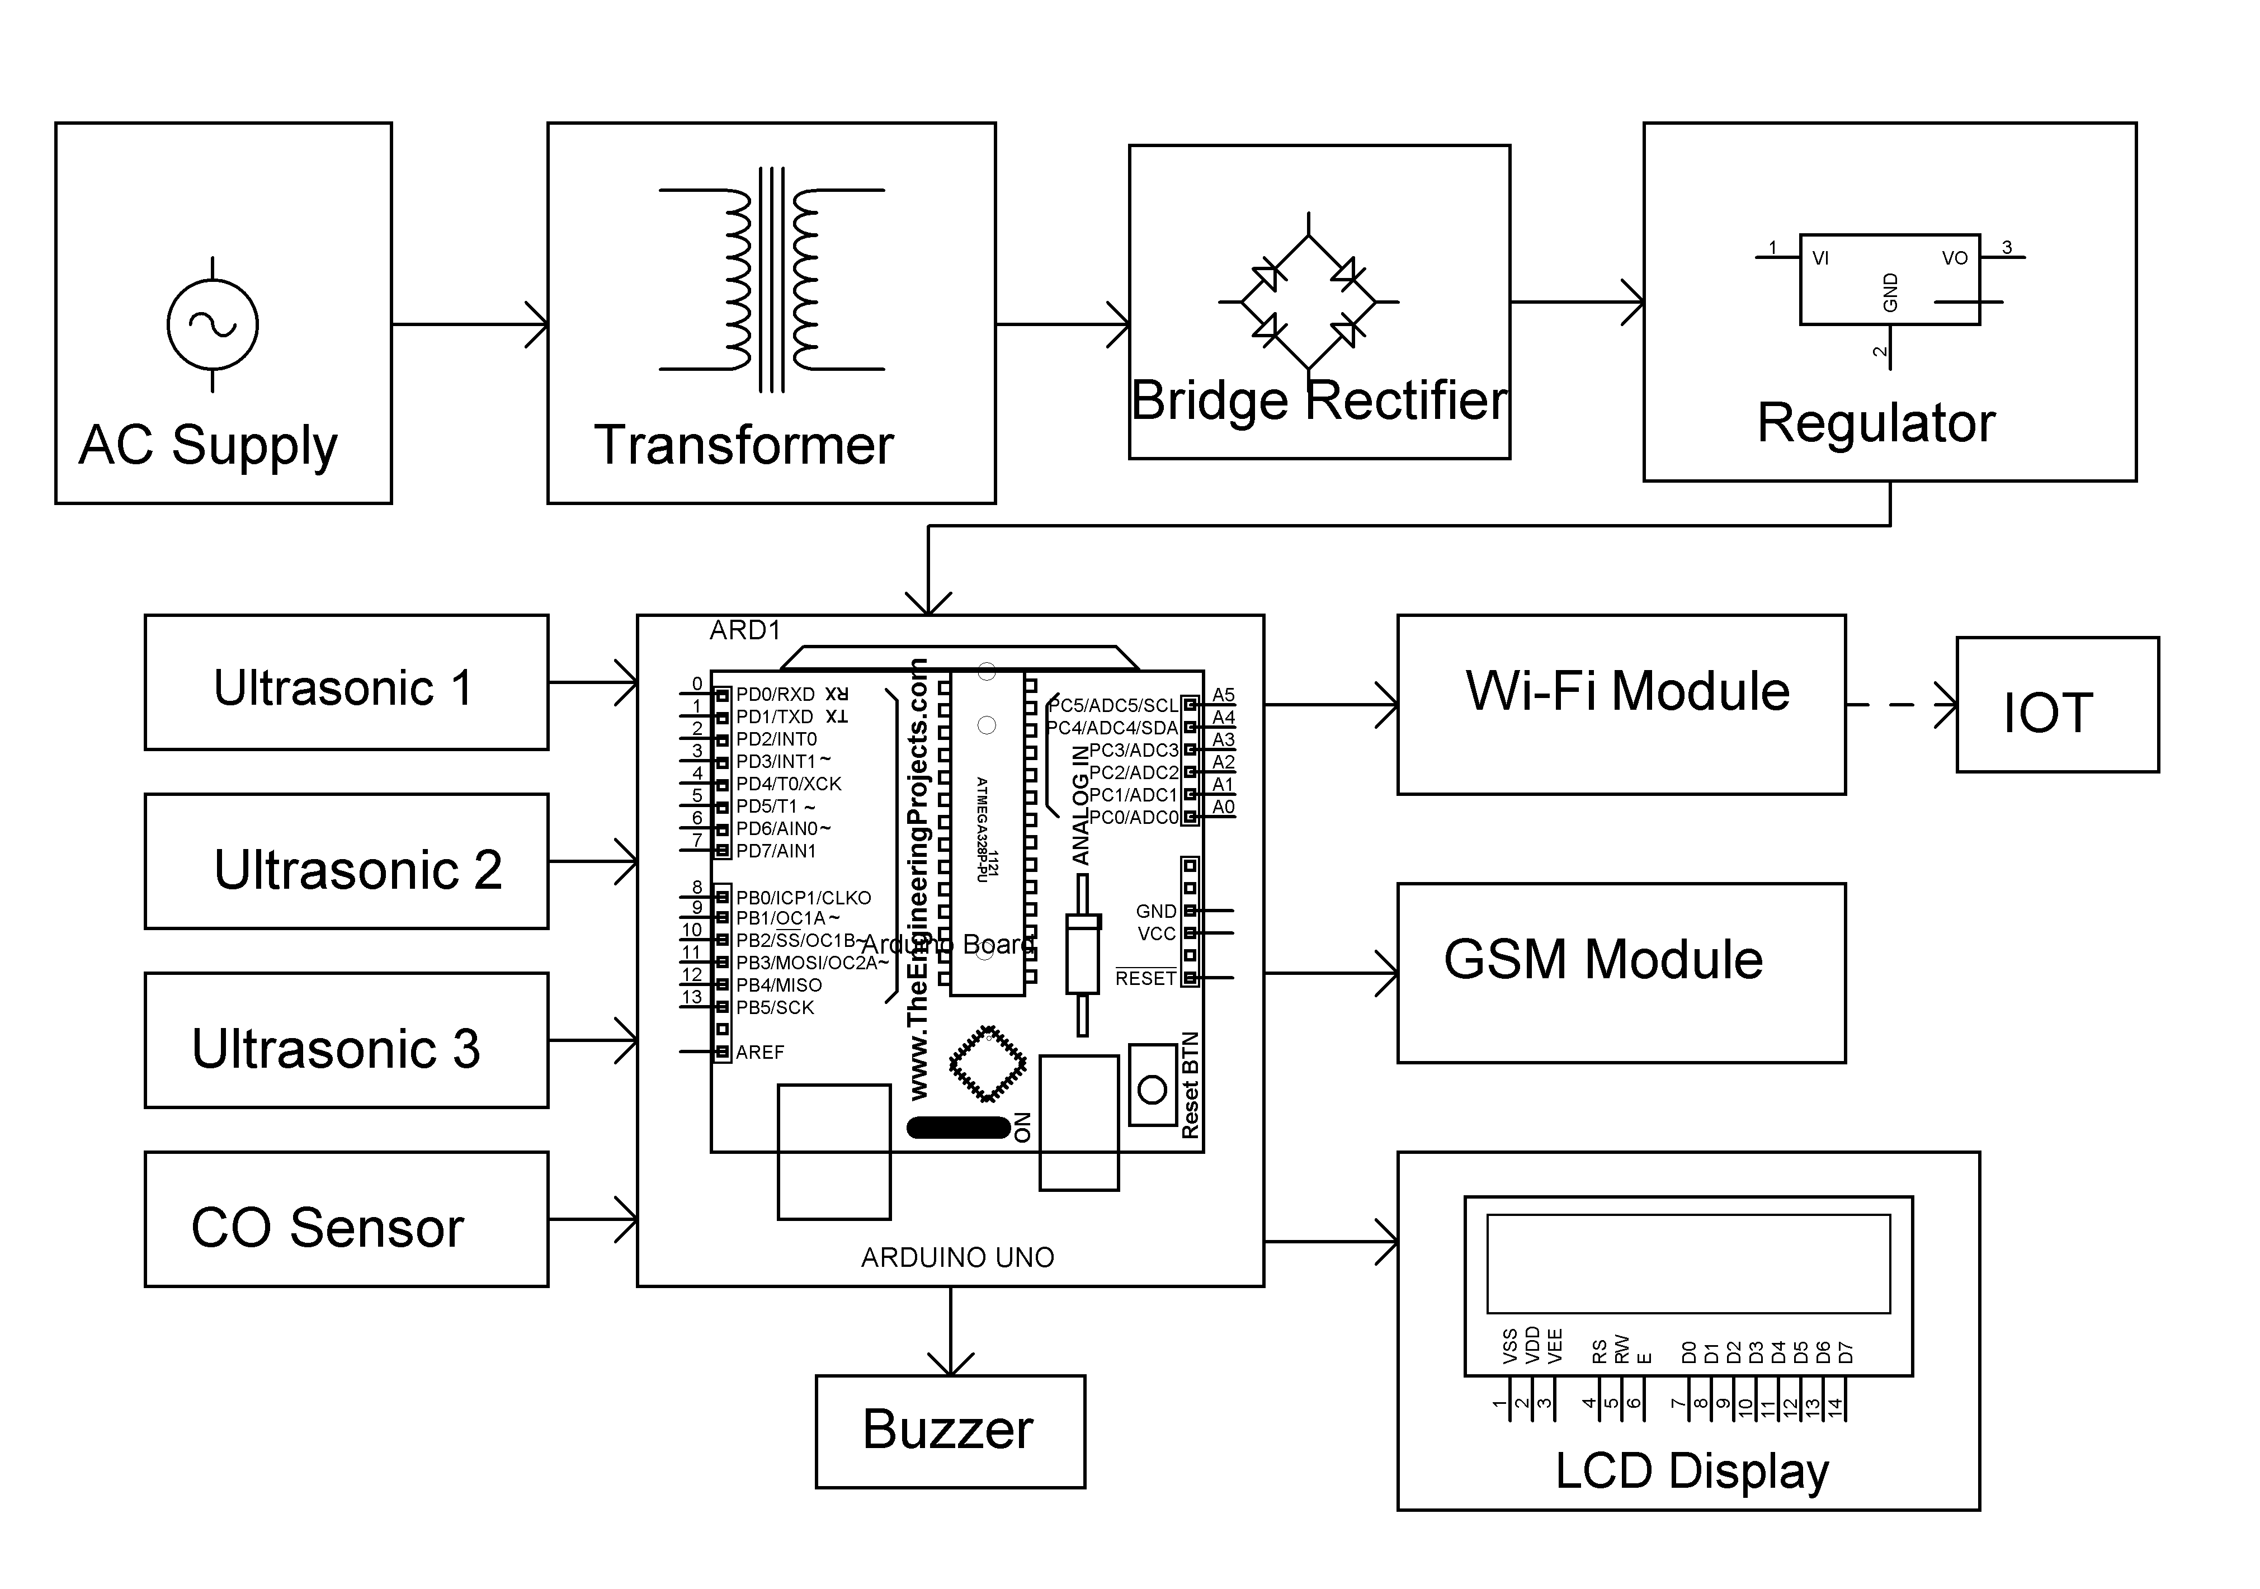

Hardware Specifications
- ATmega328P AVR MC
- HC-SR04 Ultrasonic
- ESP8266 Wifi Module
- Buzzer
- LCD’s
- Crystal Oscillator
- Resistors
- Capacitors
- Transistors
- Cables & Connectors
- Diodes
- PCB
- LED’s
- Transformer/Adapter
- Push Button

Software Specifications
- Arduino Compiler
- MC Programming Language: C
- IOT Platform: IOT thinspeak

