AUTOMATIC POWER FACTOR COMPENSATION (APFC) FOR INDUSTRIAL POWER USE TO MINIMIZE PENALTY

ABSTRACT:
In this proposed system, two zero crossing detectors are used for detecting zero crossing of voltage and current. The project is designed to minimize penalty for industrial units using automatic power factor correction unit. The microcontroller used in this project belongs to 8051 family.
The time lag between the zero-voltage pulse and zero-current pulse is duly generated by suitable operational amplifier circuits in comparator mode is fed to two interrupt pins of a microcontroller. The program takes over to actuate appropriate number of relays from its output to bring shunt capacitors into load circuit to get the power factor till it reaches near unity. The capacitor bank and relays are interfaced to the microcontroller using a relay driver. It displays time lag between the current and voltage on an LCD. Furthermore, the project can be enhanced by using relay control to avoid contact pitting often encountered by switching of capacitors due to high in rush current.

BLOCK DIAGRAM:

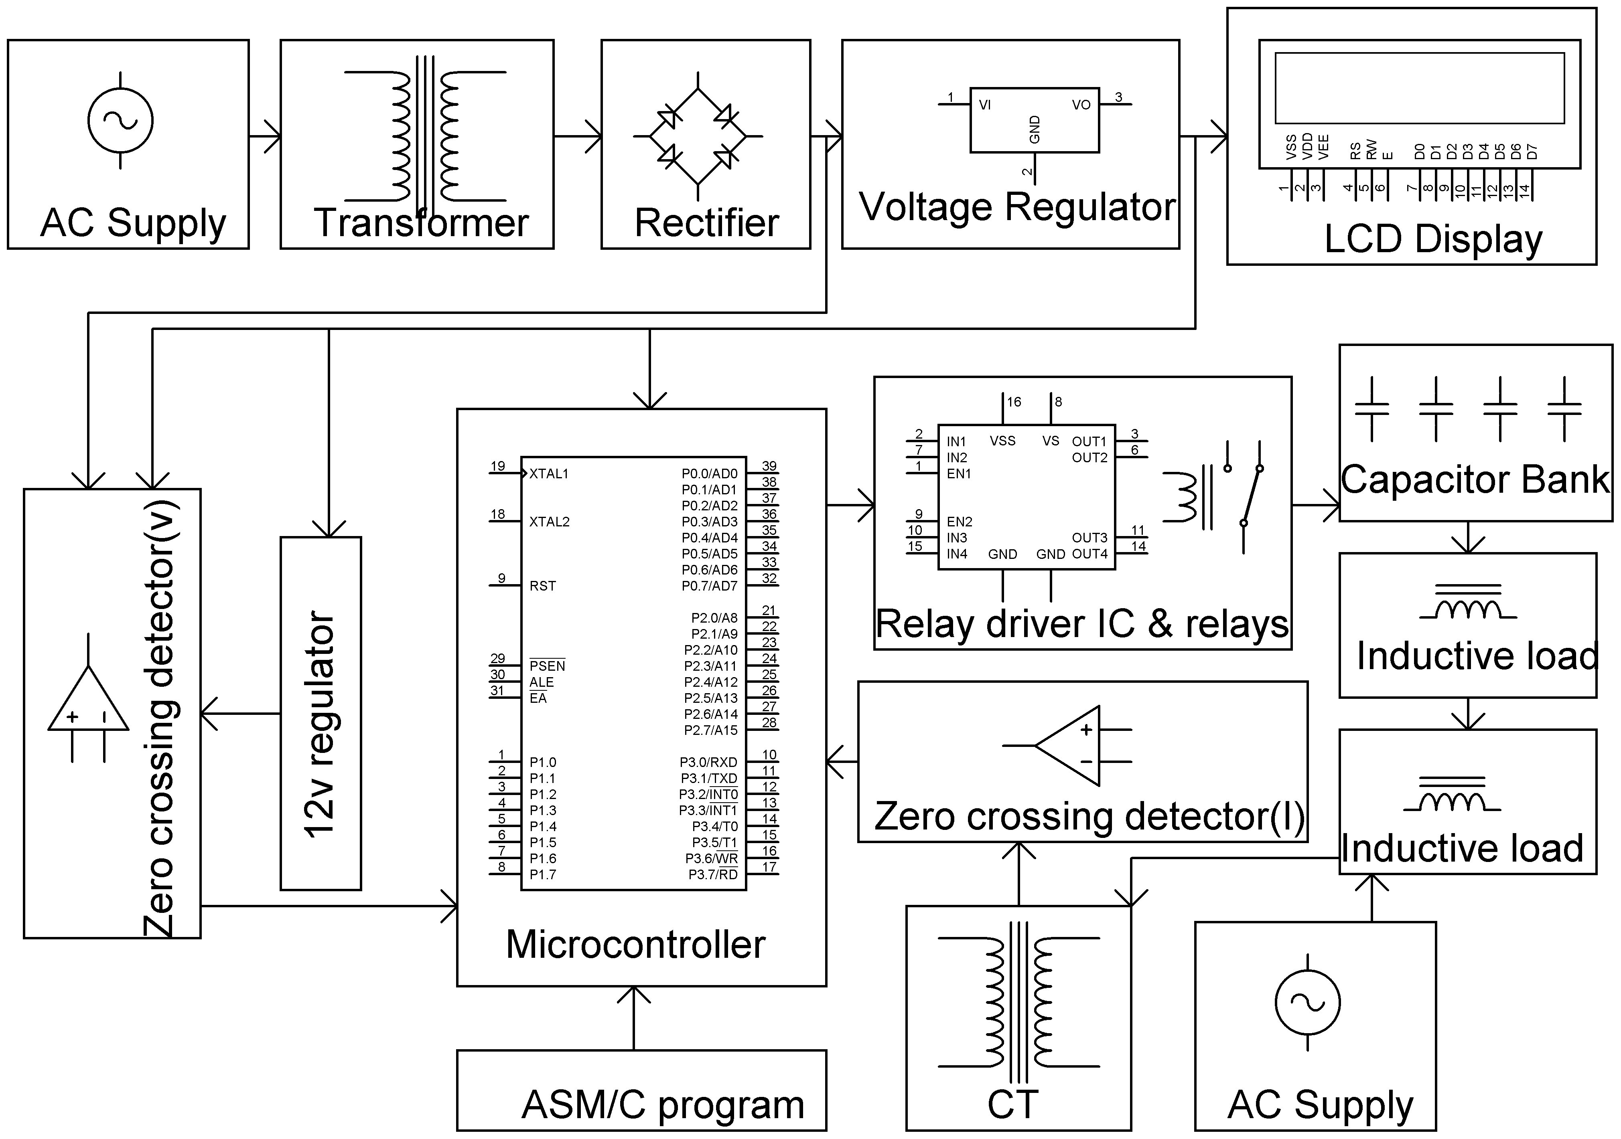

HARDWARE REQUIREMENTS:
8051 series Microcontroller,
Op-amps, LCD,
Shunt Capacitors,
Relays,
Relay driver IC,
Choke,
Crystal,
Switches,
Resistors,
Capacitors,
Diodes,
Transformer,
Voltage Regulator
Lamp

SOFTWARE REQUIREMENTS:
Keil compiler

Languages: Embedded C or Assembly

