OPTIMUM ENERGY MANAGEMENT BASED ON COUNTER, LIGHT INTENSITY & TEMPERATURE SENSOR

ABSTRACT:
The project is designed for optimum energy management based on counter, light intensity and temperature sensor. The system also counts the number of persons entering and leaving the room and displays that information on LCD display. Depending on person’s entry as well as exiting condition the room appliances will play their role. The ultimate objective of this system is to save the energy as well as to design automatic room light controller by turning off all the appliances when nobody is there in the home.
In this project we are using arduino UNO, LDR sensor, DHT-11 sensor, IR sensors, LCD display, fan and lamp. There are two pair sensors, each kept at certain distance from the other. One pair of sensor consists of a transmitter and a receiver, kept exactly opposite to each other. The transmitting part emits modulated IR light which is received at the receiver end and fed to a microcontroller of arduino UNO family. When a person enters the room arduino senses it (with the help of IR sensors) and increments the count and displays it on LCD. If LDR sensor is in dark condition then the lamps of room gets ON. This system possesses two sets of IR LED and IR sensors to detect the persons entering and leaving the room. So if the person goes outside of the room then the lamp will get OFF.
Similarly, when temperature sensor sensed the temperature then the signal goes to the arduino board and through arduino board the fan gets ON. If nobody is present in the room then it will sensed by arduino and it will turn off the fans.
This helps in saving lot of energy.
Further the project can be enhanced by using timer arrangement in the project so that if the load switching doesn’t take place for some reason as desired, then timer would complete the task after prefixed time.
BLOCK DIAGRAM:
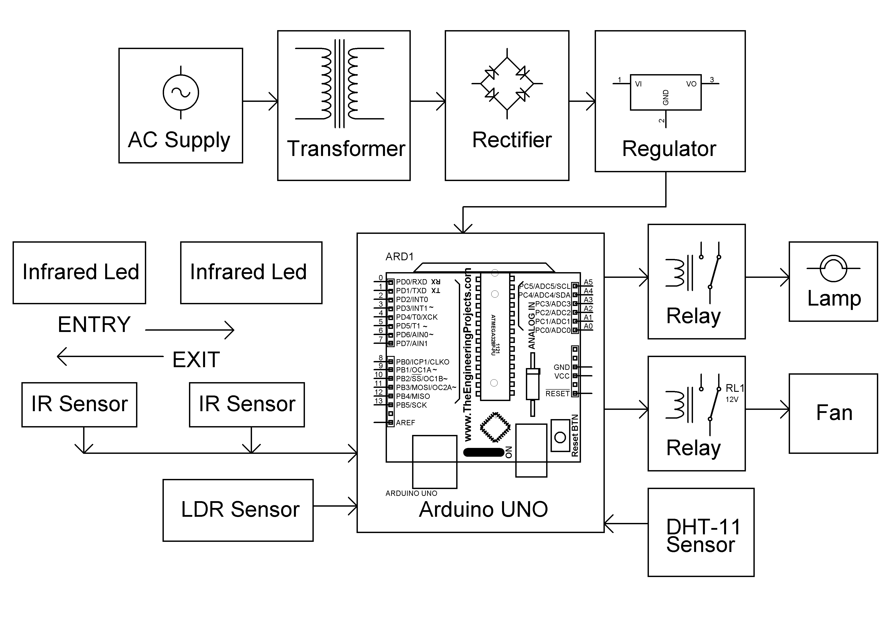
BLOCK DIAGRAM:
