ACKERMAN STEERING MECHANISM

Abstract: - There are many types o steering mechanisms used in automotive vehicles. In this project we have made prototype of Ackerman steering mechanism. When a vehicle is turning, the inner front wheel needs to turn at a different angle to the outer because they are turning on different radii. The Ackermann steering mechanism is a geometric arrangement of linkages in the steering of a vehicle designed to turn the inner and outer wheels at the appropriate angles.
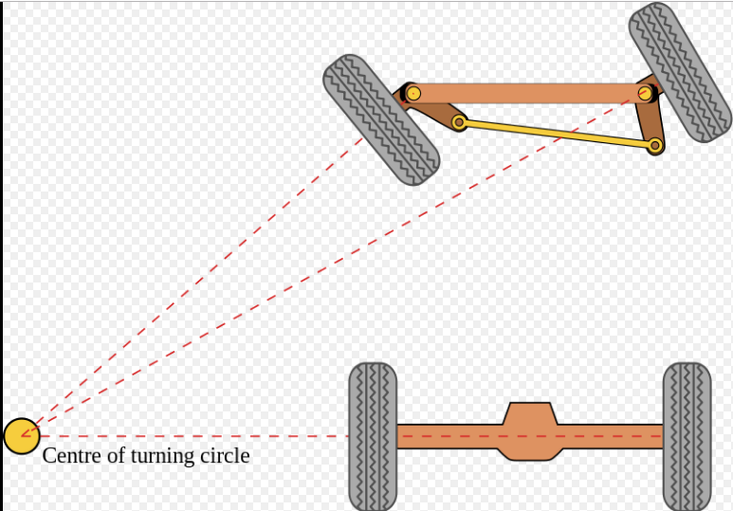
Ackerman geometry

