Solar Based UPS Project

Here we propose a solar based ups project that uses solar energy to charge battery and then the DC battery is used to power an AC load using inverter.
Our solar panel is used to constantly charge the 12V DC battery using charge controller circuitry. And once we turn on the load switch the battery charge is inverted
and stepped up from 12V DC to around 140 – 150 V AC. This is now provided to the AC load. Thus our system successfully powers AC load using a solar panel and battery.

Block Diagram:
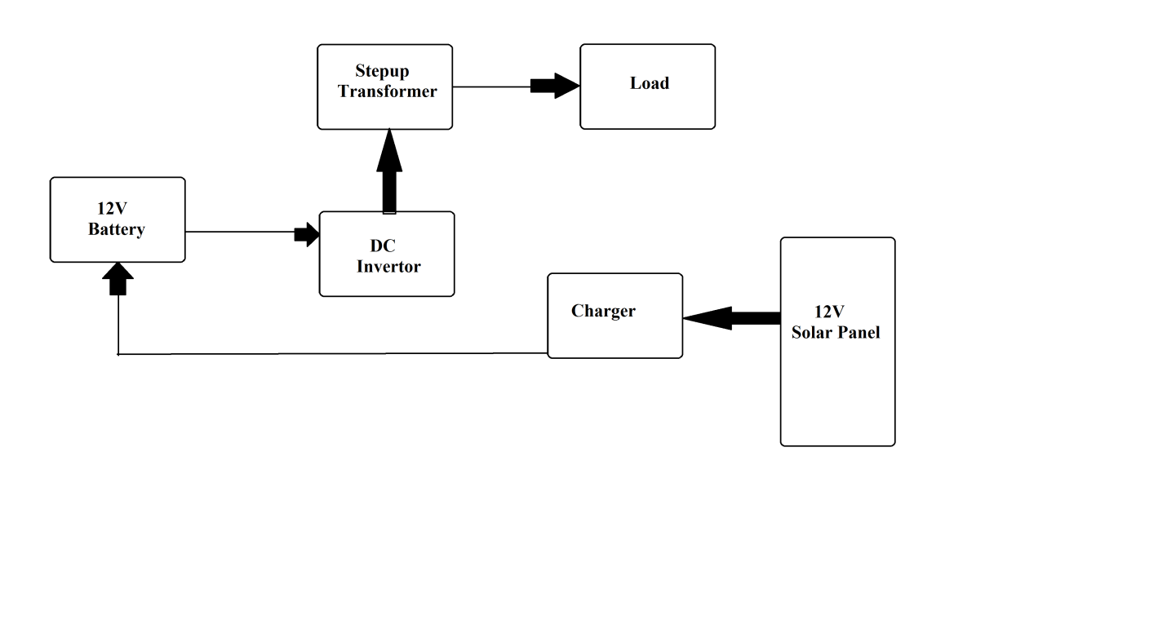
Hardware Specifications:
- 12V Solar Panel
- Transformer
- Invertor
- Resistors
- Capacitors
- Diodes
- Wires
- Lamp Base

