ELECTRONIC SOFT START OF 3 PHASE INDUCTION MOTOR

ABSTRACT

The project is designed to provide a soft and smooth start to a 3 phase induction motor. The three phase induction motor during the initial starting condition draws up much higher current than its capacity and the motor instantly reaches the full speed. This results in a mechanical jerk and high electrical stress on the windings of the motor. Sometimes the windings may get burnt. The induction motor should start smoothly and gradually catch up the speed for a safer operation. This project is designed to give a soft start to the induction motor based on the SCR firing triggered by heavily delayed firing angle during starting and then gradually reducing the delay till it reaches zero voltage triggering. This results in low voltage during start and then gradually to full voltage. Thus the motor starts slowly and then slowly picks up to full speed.
This project consists of a six anti-parallel SCRs, two for each phase, the output of which is connected to a set of lamps representing the coils of a 3 phase induction motor. The charging and discharging of capacitors is interfaced to comparators resulting in delayed firing pulses during start and then gradually reducing the delay till the motor runs at full speed. Output from the comparators is fed through opto-isolators to trigger the SCRs.
Further the project can be enhanced by using IGBTs in place of SCRs with PWM control to reduce harmonic distortions often encountered in SCR triggering mechanism.

BLOCK DIAGRAM

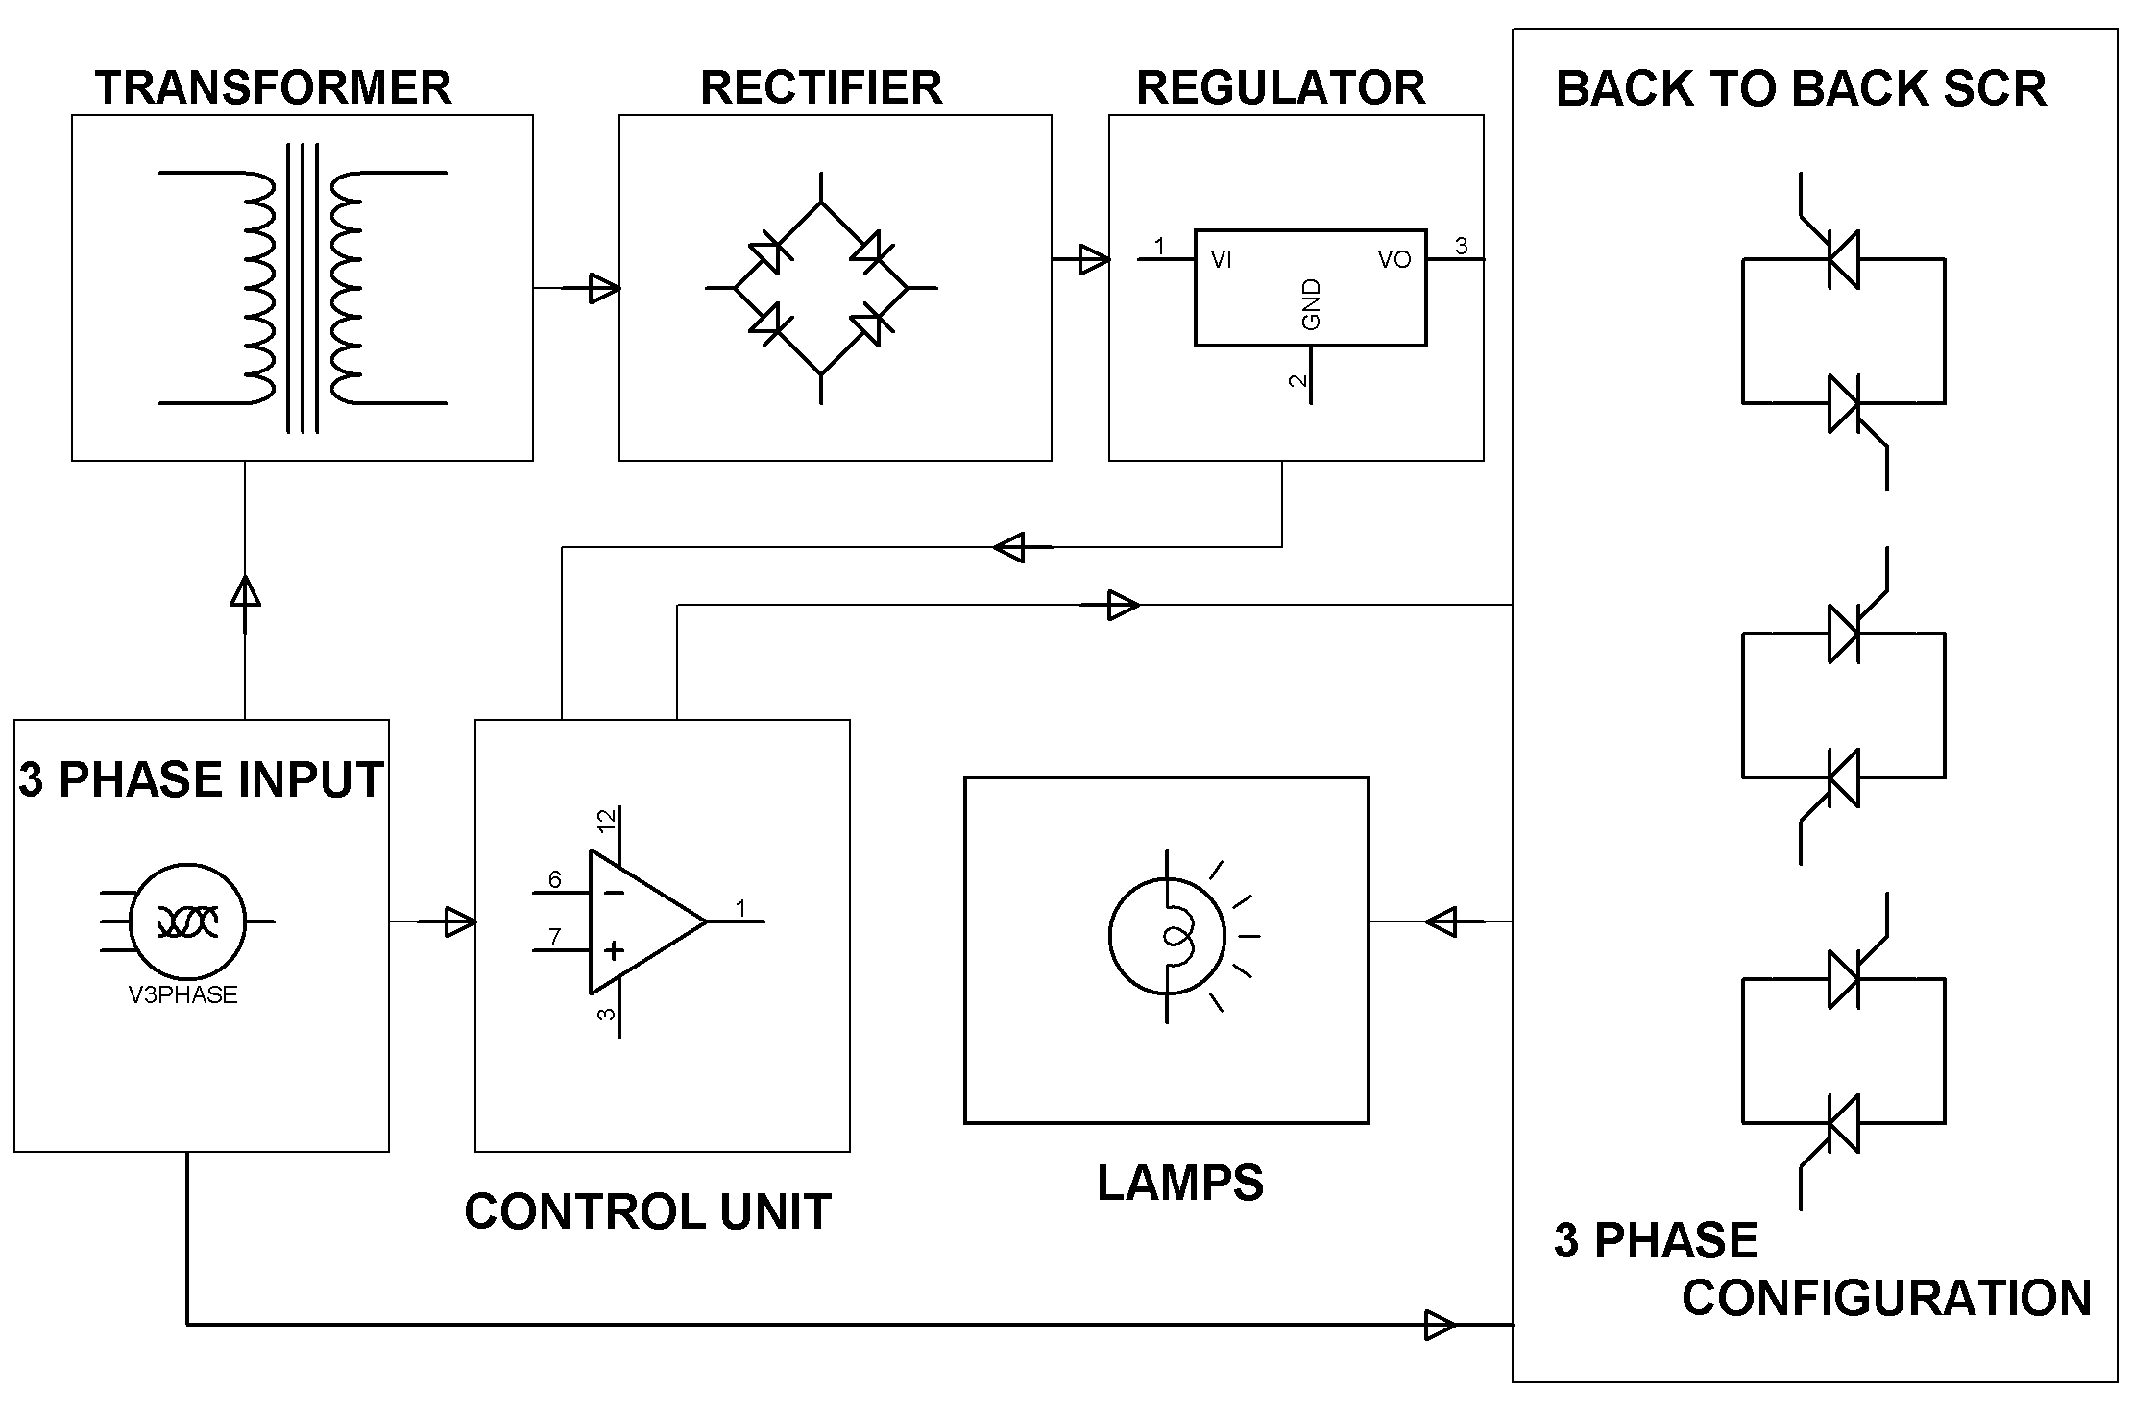
HARDWARE REQUIREMENTS:

Op-amps as comparators, Opto-isolators, Thyristors, Transistors, Regulator, Diodes, Transformers, Resistors, Capacitors, LEDs, Lamps.

